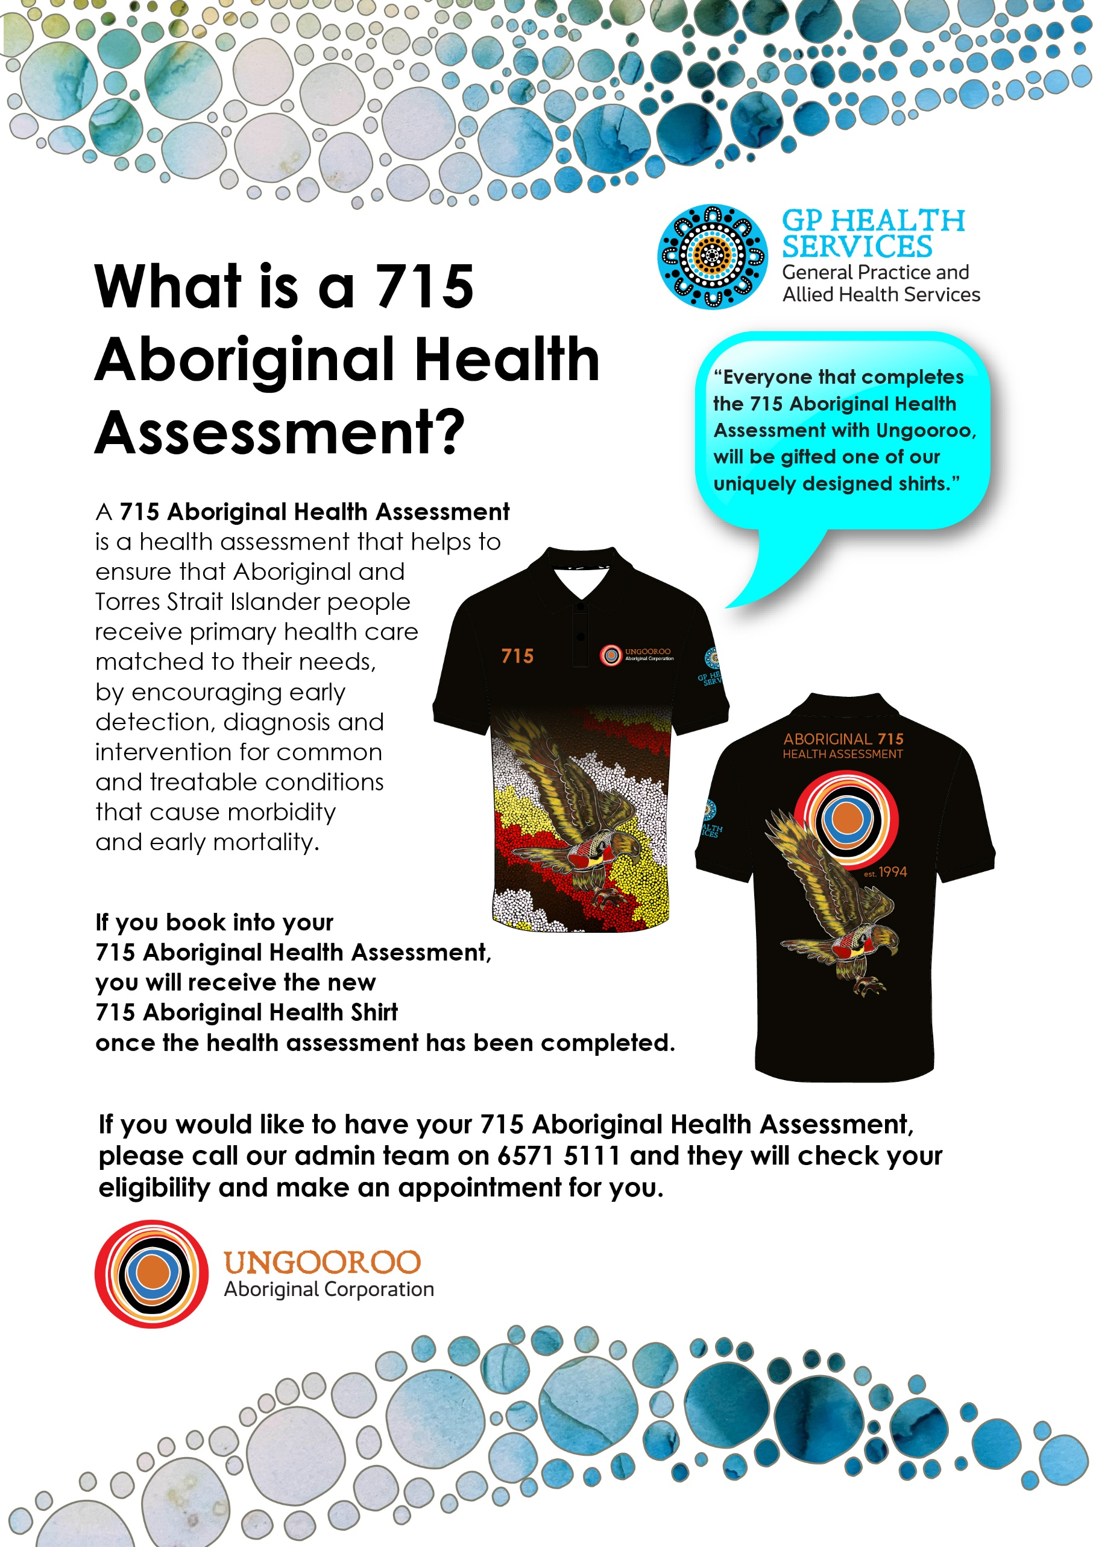

NEW PATIENT REGISTRATION AND CONSENT FORM
We are committed to providing the best care for our patients. To do so, it is essential that your health record contains complete and accurate information. Please fill out this form completely.
PERSONAL INFORMATION (Please complete all relevant boxes, if not applicable put N/A)
Title: | ☐ Mr ☐ Mrs ☐ Miss ☐ Ms |  |  |  |  |  | Middle Name:
Surname: |  |  |  |  |  |  | Preferred Name:
First Name: |  |  |  |  |  |  | Date of Birth:
Birth Sex: | ☐ Male ☐ Female |  |  |  |  |  | Gender Identity:
Country Of Birth:
Street Address:
Mobile Phone: |  |  |  | Home Phone: |  |  |  | Work Phone:
Email:
Pronouns: | ☐ She/Her/Hers ☐ He/Him/His ☐ They/Them/Their ☐ Other:
ETHNICITY (tick applicable box)
☐ Aboriginal ☐ Torres Strait Islander ☐ Aboriginal & Torres Strait Islander ☐ Australian, non-indigenous
☐ Other:
Preferred Language ☐ English ☐ Other (please advise):
Do you require an Interpreter Service? ☐ Yes ☐ No
If Yes to interpreter required, which type of service is required: ☐ Language ☐ AUSLAN
If Language interpreter required, which language:
HEALTHCARE IDENTIFIERS
Medicare No.: |  |  |  |  |  |  | Ref# on card: |  |  | Expiry Date:
Dept. of Veterans Affairs File No.: |  |  |  |  |  |  | Card Colour:
Concession Card No.: |  |  | ☐Pension ☐Health Care |  |  |  |  |  |  | Expiry Date:
Private Health Insurance No.: |  |  |  |  |  |  | Private Health  Fund Name:
NEXT OF KIN
Name: |  |  |  |  |  | Relationship to you:
Home phone: |  |  |  |  |  | Mobile phone:
EMERGENCY CONTACT
Name: |  |  |  |  |  | Relationship to you:
Home phone: |  |  |  |  |  | Mobile phone:
Patient Consent
Please read this consent form carefully prior to signing.
This general practice collects information from you for the primary purpose of providing quality health care. We require you to provide us with your personal details and a full medical history so that we may properly assess, diagnose, and treat illnesses and medical conditions, ensuring we are proactive in your health care. To enable ongoing care, and in keeping with the Privacy Act 1988 and Australian Privacy Principles, we wish to provide you with sufficient information on how your personal information may be used or disclosed and record your consent or restrictions to this consent.
Your personal information will only be used for the purposes for which it was collected or as otherwise permitted by law, and we respect your right to determine how your information is used or disclosed.
The information we collect may be collected by a number of different methods and examples may include medical test results, notes from consultations, Medicare details, data collected from observations and conversations with you, and details obtained from other health care providers (e.g., specialist and allied health correspondence).
By signing below, you (as a patient/parent/guardian or carer) are consenting to the collection of your personal information, and that it may be used or disclosed by the practice for the following purposes:
- Administrative purposes in the operation of our general practice.
- Billing purposes, including compliance with Medicare requirements.
- Follow-up reminder/recall notices for treatment and preventative healthcare, frequently issued by SMS.
- Disclosure to others involved in your health care, including treating doctors and specialists and allied health providers outside this medical practice. This may occur through referral to other doctors, or for medical tests and in the reports or results returned to us following the referrals.
- Accreditation and quality assurance activities to improve individual and community health care and practice management.
- For legal related disclosure as required by a court of law.
- For the purposes of research only where de-identified information is used.
- To allow medical students and staff to participate in medical training/teaching using only de-identified information.
- To comply with any legislative or regulatory requirements, e.g., notifiable diseases.
- For use when seeking treatment by other doctors in this practice.
- Consent to upload shared health summaries as part of the E- Health record system
- Consent to be registered for CTG where applicable (access to reduce fees for medications)
- Consent to be registered on Practice Incentive Program (PiP) for those with chronic disease
- Consent to third party communications such as appointment reminders from HOTDOC and Best Practice SMS service
- Consent to Telehealth Consultations (phone or video), authorisation of billing to be paid to treating General Practitioners
At all times we are required to ensure your details are treated with the utmost confidentiality. Your records are very important, and we will take all steps necessary to ensure they remain confidential.
Please complete the form below if you understand and agree to the statements in relation to our use, collection, privacy, and disclosure of your patient information.
I have read and given permission for the information above and understand the reasons why my information must be collected, and the purposes for which my information may be used or disclosed. I understand that if my information is to be used for any purpose other than that set out above, my further consent will be obtained.
Patient Name (in full):
Consent: (if patient is underage, please complete Parent / Carer/ Guardian – Full Name section)
Parent / Carer/ Guardian –
Full Name:
Relationship to patient:
Signature: |  | Date:

PRACTICE USE ONLY: Witnessed by: (staff name and Signature)

